
NAMA:__________________ KELAS: _______

Bahasa Indonesia

Yr 8: Viewing, Reading & Responding
Assessment Term One

Total mark:  60 | % | Weight  20%
My estimated score out of 60: ____________

Time: 2 minutes reading + 30 minutes writing

Respond appropriately to each task given.

1. Label each of the sports images below with the appropriate Indonesian translation for each sport.
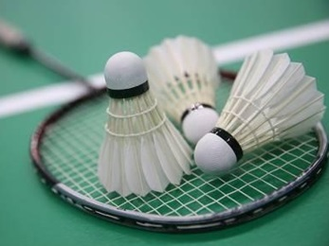
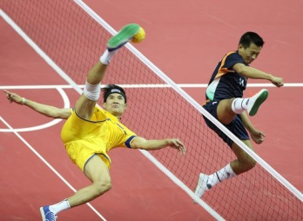
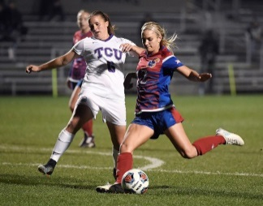
(6 Marks)

__________________ __________________ __________________

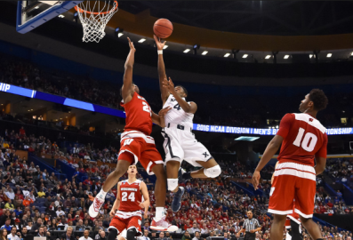



__________________ __________________ __________________

2. Translate the following sentences into Indonesian.

(a) My favourite sport is……
________________________________________________ (4 Marks)

(b) Your serve. ___________________________
(c) I watch ___________________________
(d) We play ___________________________ (6 Marks)

(e) They don’t like ___________________________ (3 Marks)

3. Translate the following sentences into English.

(a) Kamu jendang bola. ___________________________________________
(b) Buang dan menangkap itu. ___________________________________________
(c) Bermain bersama-sama. ___________________________________________
(9 Marks)

4. Translate the following sentences into Indonesian.

(a) Go and play. ___________________________________________
(b) Run fast. ___________________________________________
(c) Stop and watch. ___________________________________________
(8 Marks)

5. In this section, create some Indonesian sentences. Each sentence must contain at least four Indonesian words (you can use more if you wish), one of which must be the word presented in brackets displayed at the start of the lettered task.

e.g. (suka): Saya suka bermain olahraga.

(a) (akan): ____________________________________________________________________
__________________________________________________________________________
(4 Marks)

(b) (tetapi): ____________________________________________________________________
__________________________________________________________________________
(4 Marks)

(c) (meskipun): ________________________________________________________________
__________________________________________________________________________
(4 Marks)

(d) (berhenti): ________________________________________________________________
__________________________________________________________________________
(4 Marks)

(e) (lalu): ________________________________________________________________
__________________________________________________________________________
(4 Marks)

(f) (pada hari): ________________________________________________________________
__________________________________________________________________________
(4 Marks)

